DDD Assignment

To put in a client name select all (ctrl A) then f9Nash Tech Software Development

**Detailed Design**

**Version 1.0**

**25th Nov, 2013**

13 Bruton Street

London

W1J 6QA

Tel: +44 (0)20 7333 0033

Fax: +44 (0)20 7333 0032

Email: [Tim.lewis@harveynash.com](mailto:Tim.lewis@harveynash.com)

DOCUMENT HISTORY

|  |  |  |  |  |
| --- | --- | --- | --- | --- |
| **Document Version History** | | | | |
| **Version** | **Date** | **Author** | **Reviewer** | **Details** |
| 0.1 | 25 Nov 2013 | Thai Nguyen |  | Create |

**APPROVERS**

|  |  |  |  |
| --- | --- | --- | --- |
|  | Name & Role | Date | Signature |
| **Originator** |  |  |  |
| **Reviewer/s** |  |  |  |
| **Approver/s** |  |  |  |

**CONFIDENTIALITY**

This document is distributed on a restricted basis, is commercial in confidence to the recipient, and may not be used for any purpose other than that associated with a Nash Tech project. The contents of this document may not be disclosed to any third parties without the expressed advance written authorisation of Nash Tech.

TABLE OF CONTENTS

1 INTRODUCTION 2

1.1 Purpose 2

1.2 Scope 2

1.3 Definitions, Acronyms and Abbreviations 2

1.4 References 2

1.5 Overview 2

2 DESIGN SEPECIFICATION FOR <THE SPECIFIED USE CASE> 2

2.1 Summary 2

2.2 Use case diagram 2

2.3 Activity Diagram 2

2.4 Sequence Diagram 2

2.5 Screens Design 2

2.5.1. Screen XYZ 2

2.6 Class Diagram 2

2.7 Class Specification (s) 2

2.7.1. Classes Summary 2

2.7.2. Class Details 2

**2.7.2.1.** **Class XYZ** 2

**2.7.2.1.1.** **Attributes** 2

**2.7.2.1.2.** **Methods** 2

**2.7.2.1.3.** **[XXX] Method** 2

# INTRODUCTION

[The introduction of the Detailed Design Document should provide an overview of the entire Document. It should include the purpose, scope, definitions, acronyms, abbreviations and references.]

## Purpose

[This section defines the purpose of the Detailed Design Document, in the overall project documentation, and briefly describes the structure of the document. The specific audiences for the document should be identified, with an indication of how they are expected to use the document.]

## Scope

[A brief description of what the Document applies to; what is affected or influenced by this document.]

## Definitions, Acronyms and Abbreviations

[This subsection should provide the definitions of all terms, acronyms, and abbreviations required to properly interpret the Document. This information may be provided by reference to the project Glossary.]

|  |  |
| --- | --- |
| **Acronym** | **Reference** |
| IO | Input/Output |
| UI | User Interface |
| spi | Service provider Interface API Implementation |

## References

[This subsection should provide a complete list of all documents referenced elsewhere in the Document. Each document should be identified by title, report number (if applicable), date, and publishing organisation. Specify the sources from which the references can be obtained. This information may be provided by reference to an appendix or to another document.]

## Overview

[This subsection should describe what the following sections of the Document contain and explain how the Document is organised.]

# DESIGN SEPECIFICATION FOR <THE SPECIFIED USE CASE>

## Summary

### Goal

This use case provides users with the ability to create, view, discuss on a topic.

The administrator has the ability to lock, unlock, delete topic

### Brief Description

Requirements for user:

* User is required to login if he wants to discuss on a topic
* Anonymous user is able to view topics; if they want to discuss on the topic, he will be redirected to login page. After login successfully, he will be redirected to the previous topic.
* The website will be implemented using MVC 3, SQL Server 2008.
* The system will validate user by username and password. Password is encrypted using MD5.

Requirements for admin:

* Admin has full user functionalities.
* Admin can delete any topic / discussion in the same screen of user.
* Admin can lock / unlock a topic. Nobody can discuss on a locked topic except view it.

## Use case diagram

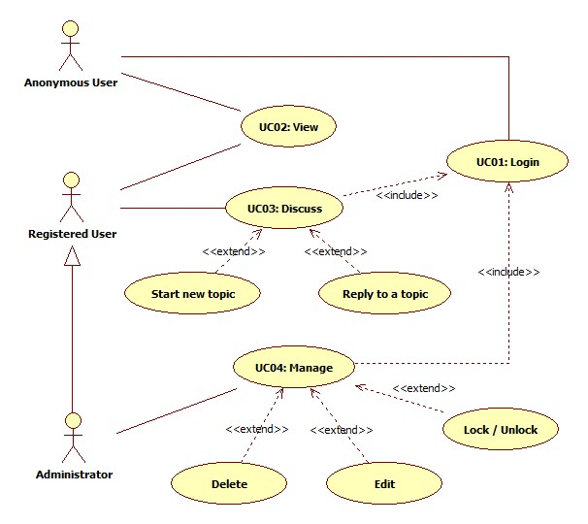

## Activity Diagram

### Login

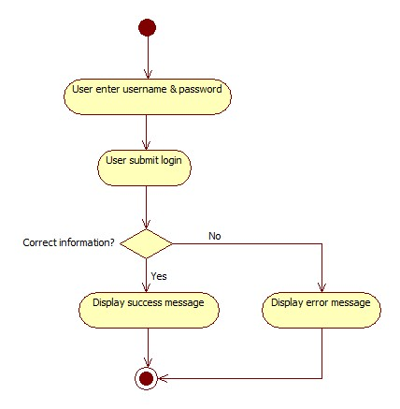

### View

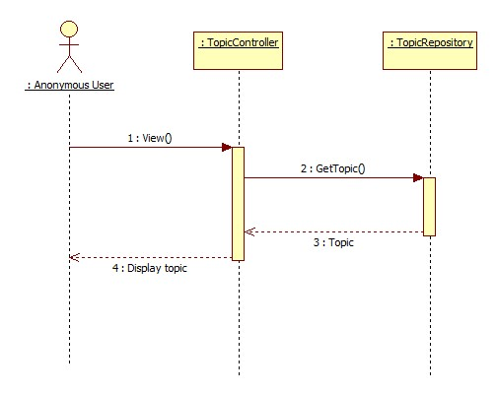

### Discuss

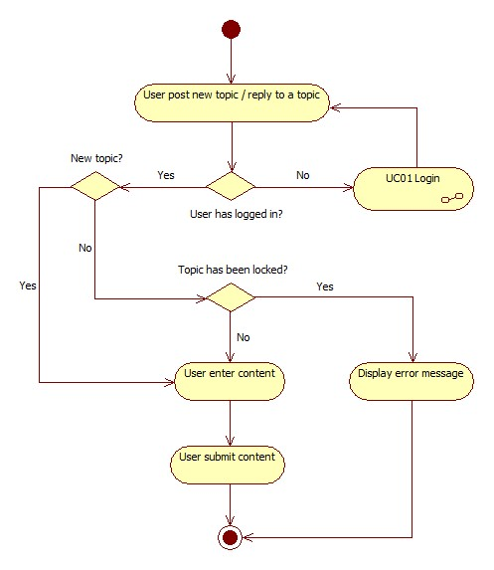

### Manage

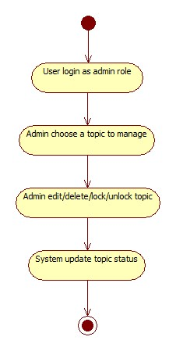

## Sequence Diagram

### Login

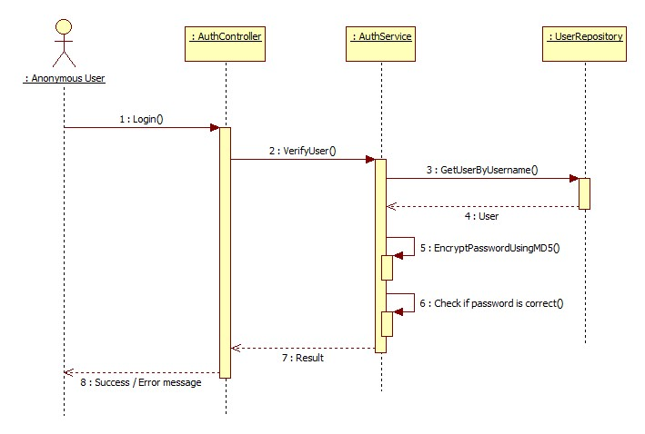

### View



### Discuss

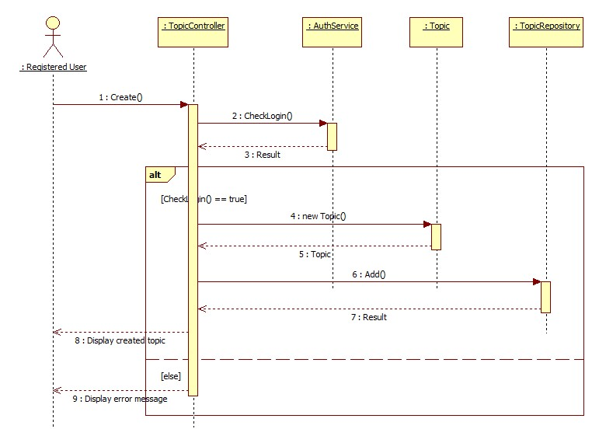

### Manage

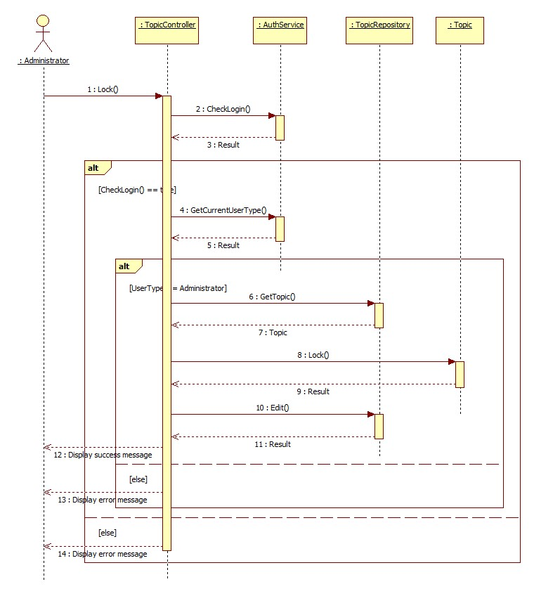

## Screens Design

### Screen XYZ

[Description the purpose of the screen as to ensure the client and developer agrees on its functionality.]

[include screen shot here]

**Security Group**: [List the security groups that may use the screen]

[Describe each field on the screen and how it is derived]

|  |  |  |
| --- | --- | --- |
| No | Data | Data Description |
| 01 | Data XYZ |  |
|  |  |  |

[Describe each action that can be performed from this screen. This usually involves command buttons, menu items, etc.]

|  |  |  |
| --- | --- | --- |
| No | Actions | Action Description |
| 01 | Action XYZ |  |
|  |  |  |

## Class Diagram

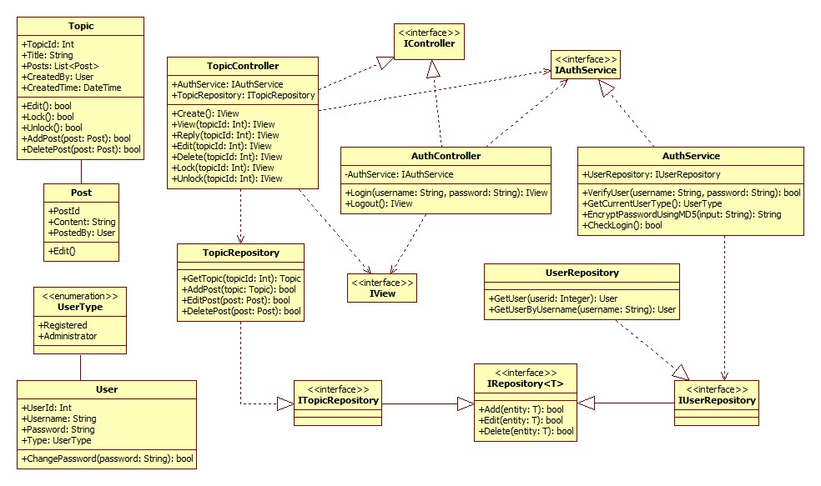

## Class Specification (s)

### Classes Summary

To be defined

### Class XYZ

To be defined

#### **Class Topic**

#### **Attributes**

|  |  |  |  |  |  |
| --- | --- | --- | --- | --- | --- |
| No | Attribute | Type | Default | Note | Description |
| 01 | [Attribute name] | int |  | Public/ Static | [Description of attribute] |
|  |  |  |  |  |  |
|  |  |  |  |  |  |

#### **Methods**

|  |  |  |
| --- | --- | --- |
| No | Method | Description |
| 01 | [Method Name] | [brief description of method. can be one sentence tell what the method does] |
| 02 | Lock | Lock topic |
| 03 | Unlock | Unlock topic |

#### **[XXX] Method**

|  |  |
| --- | --- |
| **Declaration** | |
| **Method Declaration** |  |
| **Description** |  |
| **Overrides** | |
| Not Applicable. | |
| **Parameter** | |
| **Name** | **Type** |
|  |  |
|  |  |
|  |  |
| **Return Type** | |
|  | |
| **Throws** | |
|  | |

##### Implementation

[How to implement the method, it can be in pseudo code or activity diagram or just words]